***OOP ASSIGNMENT***

***Question # 1:***

***PROGRAM:***

#include <iostream>

using namespace std;

void perfect(int x);

int main()

{

cout << "This Program will tell about the perfect number from 1 to 1000 !" << endl<<endl;

// calling the function

for(int i=1;i<=1000;i++)

perfect(i);

cout << endl << endl;

system("pause");

}

void perfect(int x)

{

int total = 0;

for (int i = 1; i < x; i++)

{

if (x%i == 0)

{

total = total + i;

}

}

if (total == x)

cout << x << " is a perfect number." << endl;

}

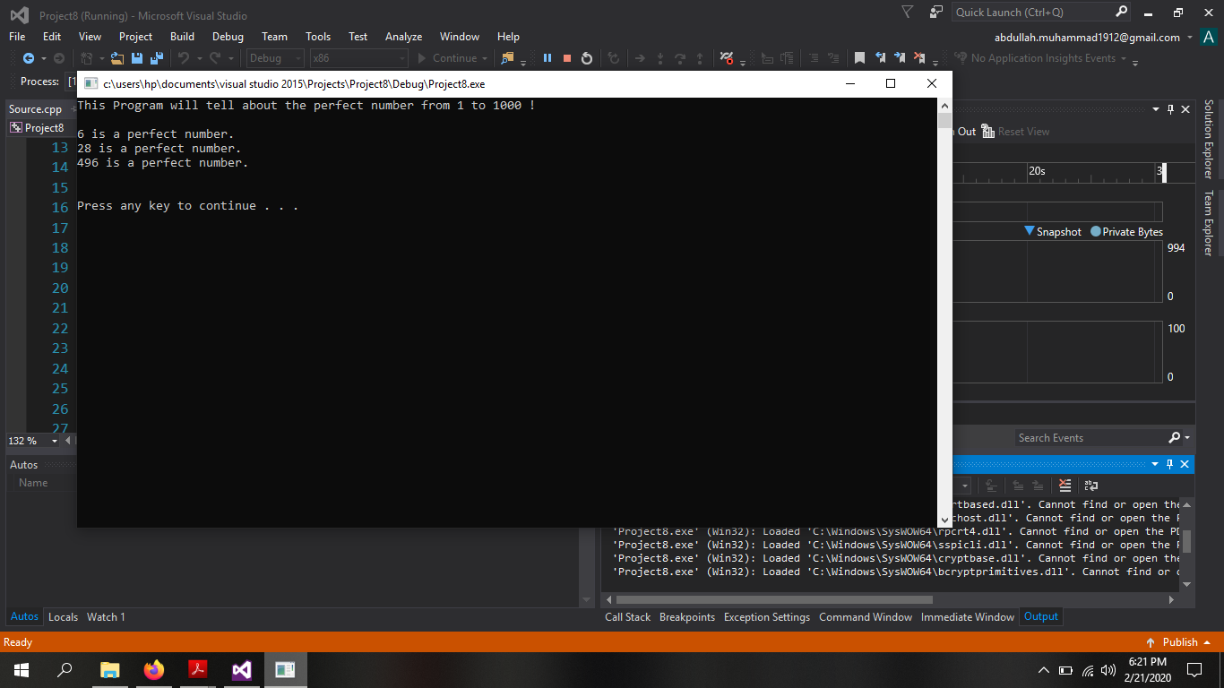

***Question # 2:***

***PROGRAM:***

#include <iostream>

using namespace std;

float sumup(float &x, float &y, float &z);

int main()

{

cout << "This Program will tell about the price of pastries !" << endl<<endl;

float x = 1.0, y = 2.0, z = 0.0;

cout << "Enter the price of pastry : ";

cin >> x;

cout << "Enter the amount of pastry you want to buy : ";

cin >> y;

cout<<"Total value of pastaries = "<<sumup(x, y, z);

cout << endl << endl;

system("pause");

}

float sumup(float &x, float &y, float &z)

{

z = x*y;

return z;

}

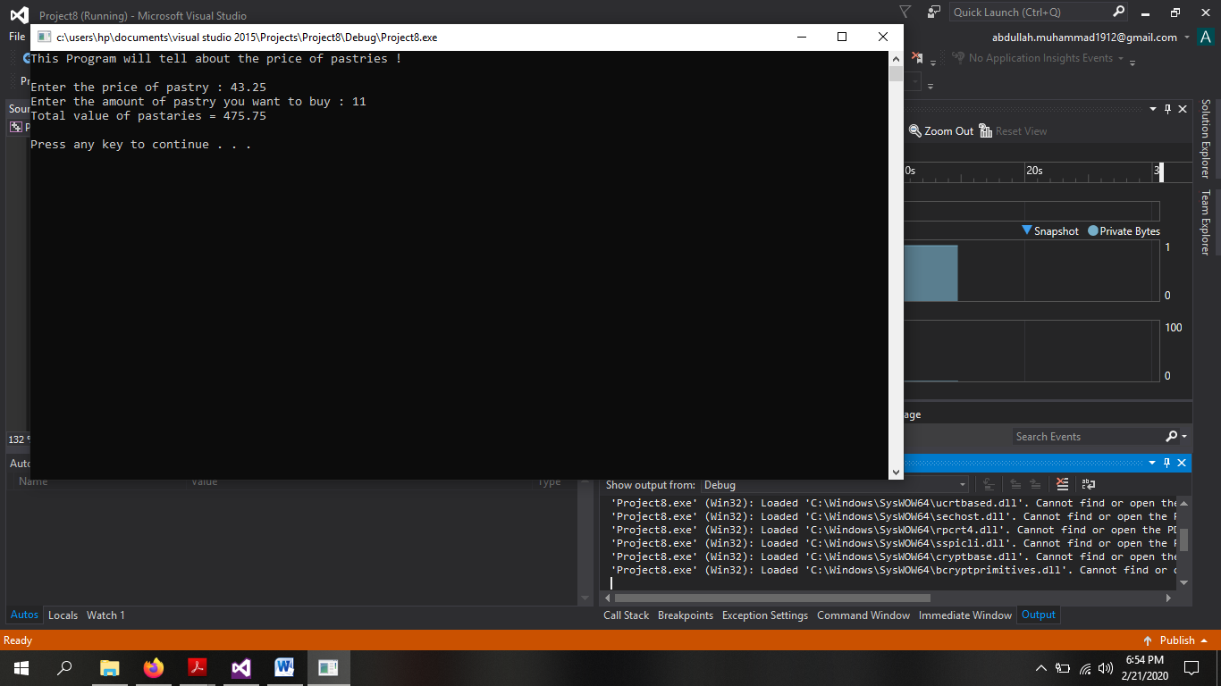

***Question # 3:***

***PROGRAM:***

#include <iostream>

using namespace std;

struct Student_Record

{

char name[30];

float quiz1;

float quiz2;

float tq; // total quiz marks

float mid1;

float mid2;

float tm; // total mids marks

float Final;

float total;

};

int main()

{

Student_Record ST;

cout << "This Program will tell about the Marks of the student !" << endl<<endl;

cout << "Enter the name of the student : ";

cin.get(ST.name, 30);

cout <<endl<< "Enter the marks of quiz 1 of "<<ST.name<<" (upto 10) : ";

cin >> ST.quiz1;

cout << "Enter the marks of quiz 2 of " << ST.name << "(upto 10) : ";

cin >> ST.quiz2;

ST.tq = ST.quiz1 + ST.quiz2; // quizes marks finalize

cout <<endl<< "Total points in quizes are : " << ST.tq;

ST.tq = (ST.tq / 20) * 25;

cout << endl << "Total marks in quizes are : " << ST.tq << endl;

cout <<endl<< "Enter the marks of mid 1 of " << ST.name << " (upto 100) : ";

cin >> ST.mid1;

cout << "Enter the marks of mid 2 of " << ST.name << " (upto 100) : ";

cin >> ST.mid2;

ST.tm = ST.mid1 + ST.mid2; // mids marks finalize

cout <<endl<< "Total points in mids are : " << ST.tm;

ST.tm = (ST.tm / 200) * 25;

cout <<endl<< "Total marks in mids are : " << ST.tm<<endl;

cout <<endl<< "Enter the marks of Final of " << ST.name << " (upto 100) : ";

cin >> ST.Final; // final marks finalize

cout << "Total marks in Finals are : " << ST.Final<<endl;

ST.Final = (ST.Final / 100) * 50;

// Getting total of all marks

ST.total = ST.Final + ST.tm + ST.tq;

cout <<endl<< "Total Marks Obtain by " << ST.name << " are : " << ST.total<<endl;

// Grading Sceheme

if (ST.total <= 100 && ST.total >= 90)

cout << ST.name << " Got A Grade ! ";

else if (ST.total < 90 && ST.total >= 80)

cout << ST.name << " Got B Grade ! ";

else if (ST.total < 80 && ST.total >= 70)

cout << ST.name << " Got C Grade ! ";

else if (ST.total < 70 && ST.total >= 60)

cout << ST.name << " Got D Grade ! ";

else if (ST.total < 60)

cout << ST.name << " Got F Grade ! ";

else

cout << "Invalid Entry ";

cout << endl << endl;

system("pause");

}

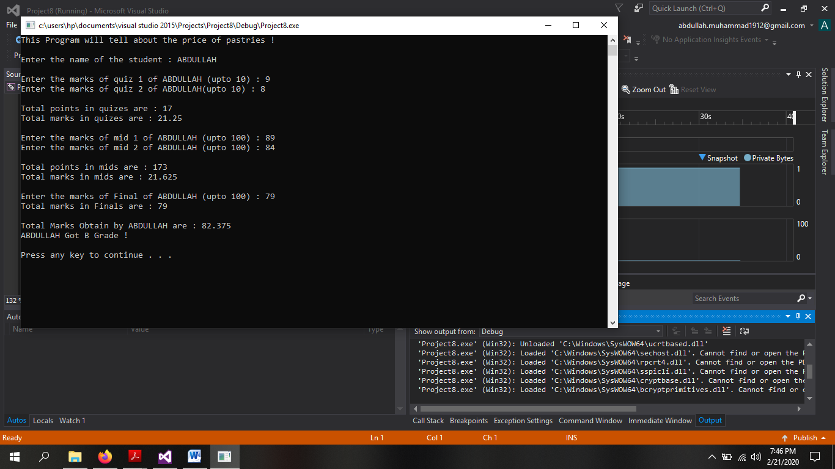

***Question # 4:***

***PROGRAM:***

#include <iostream>

using namespace std;

int stats(int *ptr, int x);

int main()

{

cout << "This Program will tell about the mode from the values !" << endl << endl;

int array[20], integer =0, a;

cout << "Enter the values into array : " << endl;

for (int i = 0; i < 20; i++)

{

cin >> array[i];

}

a = stats(array, integer);

if (a == -1)

cout << "No Mode from the values !";

else

cout << a << " is the mode from the values !";

cout << endl << endl;

system("pause");

}

int stats(int *ptr, int x)

{

int temp = 1,max=0;

x = ptr[0];

for (int i = 0; i < 10; i++)

{

if (ptr[i] == ptr[i + 1]) // array index equals to array second index

{

temp++;

if (max < temp)

{

max = temp;

x = ptr[i];

}

}

}

if (temp == 1)

return -1;

else

return x;

}

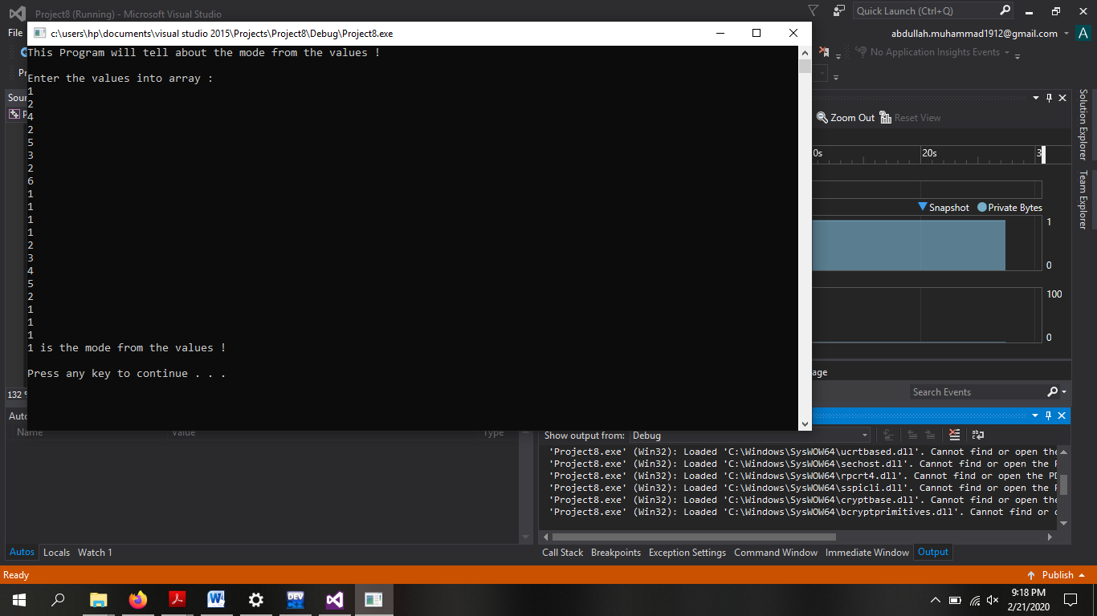

***Question # 6:***

***PROGRAM:***

#include <iostream>

using namespace std;

int main()

{

cout << "This program will help to make 2 2D Arrays !" << endl;

int **Double1 = NULL;

int **Double2 = NULL;

int **Double3 = NULL;

int row1 = 0, column1 = 0,row2 = 0,column2 = 0;

cout << "Enter the number of rows of matrix 1 : ";

cin >> row1;

cout << "Enter the number of columns of matrix 1 : ";

cin >> column1;

cout <<endl<< "Enter the number of rows of matrix 2 : ";

cin >> row2;

cout << "Enter the number of columns of matrix 2 : ";

cin >> column2;

Double1 = new int*[row1]; // 1st matrix formation

cout <<endl<< "Inputing Matrix 1 Values : " << endl;

for (int i = 0; i < row1; i++)

{

for (int j = 0; j < column1; j++)

{

Double1[i] = new int[column1];

}

}

for (int i = 0; i < row1; i++)

{

for (int j = 0; j < column1; j++)

{

cout << "Enter value of " << i + 1 << " row and " << j + 1 << " coloumn : ";

cin >> Double1[i][j];

}

cout << endl;

}

Double2 = new int*[row2]; // 2nd matrix formation

cout <<endl<< "Inputing Matrix 2 Values : " << endl;

for (int i = 0; i < row2; i++)

{

for (int j = 0; j < column2; j++)

{

Double2[i] = new int[column2];

}

}

for (int i = 0; i < row2; i++)

{

for (int j = 0; j < column2; j++)

{

cout << "Enter value of " << i + 1 << " row and " << j + 1 << " coloumn : ";

cin >> Double2[i][j];

}

cout << endl;

}

Double3 = new int*[row1]; // 3rd matrix formation

for (int i = 0; i < row1; i++)

{

for (int j = 0; j < column1; j++)

{

Double3[i] = new int[column1];

}

}

cout << "Value of Matrix 1 : " << endl;

for (int i = 0; i < row1; i++)

{

for (int j = 0; j < column1; j++)

{

cout << Double1[i][j] << " ";

}

cout << endl;

}

cout << endl;

cout << "Value of Matrix 2 : " << endl;

for (int i = 0; i < row2; i++)

{

for (int j = 0; j < column2; j++)

{

cout << Double2[i][j] << " ";

}

cout << endl;

}

int opt;

cout << endl << "Press 1 to Add both of the matrixes " << endl;

cout << "Press 2 to Subtract both of the matrixes " << endl;

cout << "Press 3 to Multiply both of the matrixes " << endl;

cout << "Option choosed : ";

cin >> opt;

cout << endl;

switch (opt)

{

case 1:

{

cout << "Addition of both Matrixes : " << endl;

for (int i = 0; i < row1; i++)

{

for (int j = 0; j < column1; j++)

{

Double3[i][j] = Double1[i][j] + Double2[i][j];

}

}

for (int i = 0; i < row1; i++)

{

for (int j = 0; j < column1; j++)

{

cout << Double3[i][j]<<" ";

}

cout << endl;

}

break;

}

case 2:

{

cout << "Subtraction of both Matrixes : " << endl;

for (int i = 0; i < row1; i++)

{

for (int j = 0; j < column1; j++)

{

Double3[i][j] = Double1[i][j] - Double2[i][j];

}

}

for (int i = 0; i < row1; i++)

{

for (int j = 0; j < column1; j++)

{

cout << Double3[i][j]<<" ";

}

cout << endl;

}

break;

}

case 3:

{

cout << "Multiplication of both Matrixes : " << endl;

for (int i = 0; i < row1; i++)

{

for (int j = 0; j < column1; j++)

{

Double3[i][j] = Double1[i][j] * Double2[i][j];

}

}

for (int i = 0; i < row1; i++)

{

for (int j = 0; j < column1; j++)

{

cout << Double3[i][j] << " ";

}

cout << endl;

}

break;

}

default:

cout << "Invalid Entry, Try Again !";

}

delete[]Double1; // De-allocating Pointers

Double1 = NULL;

delete[]Double2;

Double2 = NULL;

delete[]Double3;

Double3 = NULL;

cout << endl << endl;

system("pause");

}

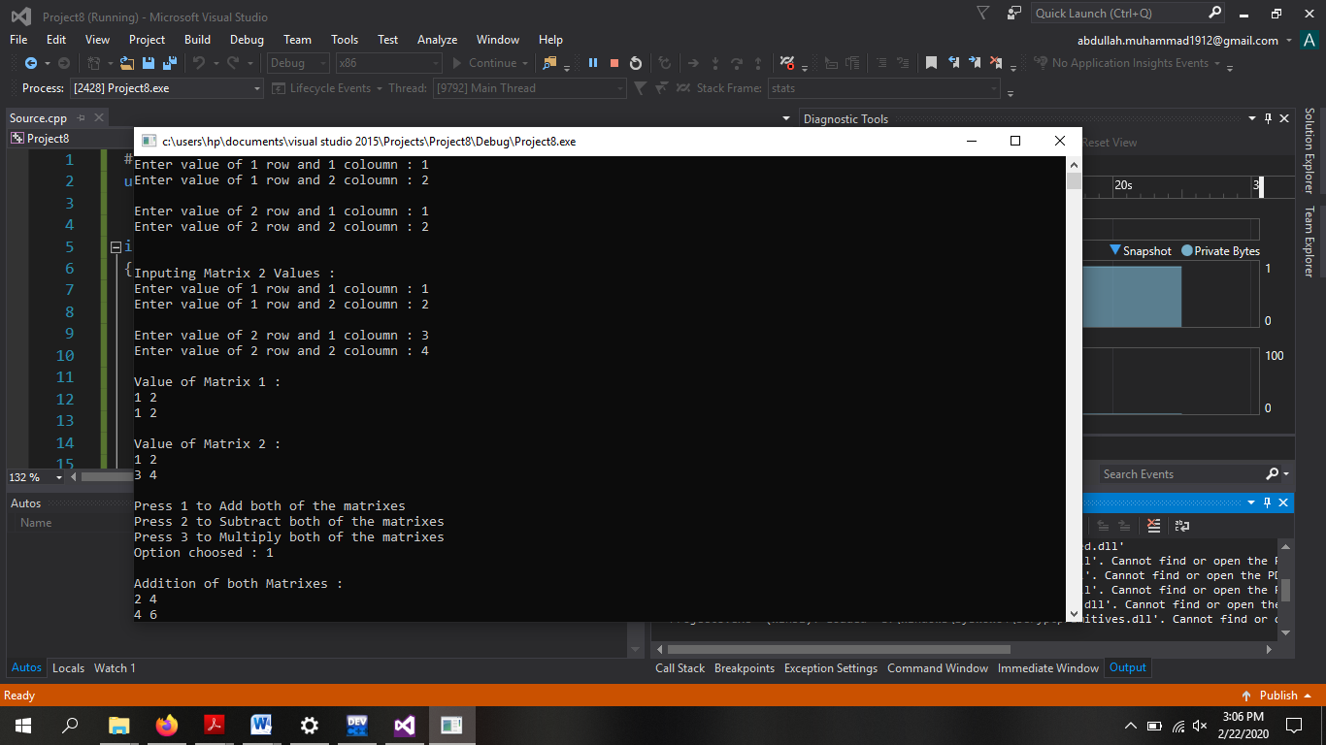

***Question # 7:***

***PROGRAM:***

#include <iostream>

using namespace std;

int main()

{

cout << "This program will make 3D array of 4*5*10 and de-allocate it !" << endl;

int ***ptr = NULL;

ptr = new int**[4];

cout << endl;

for (int i = 0; i < 4; i++)

{

ptr[i] = new int*[5];

for (int j = 0; j < 5; j++)

{

ptr[i][j] = new int[10];

}

}

cout << endl;

for (int i = 0; i < 4; i++)

{

for (int j = 0; j < 5; j++)

{

for (int k = 0; k < 10; k++)

{

cout << "Enter the value of " << i + 1 << " row, " << j + 1 << " column and " << k + 1 << " height : ";

cin >> ptr[i][j][k];

}

cout << endl;

}

cout << endl;

}

cout << endl << "The value of 3D array is : " << endl;

for (int i = 0; i < 4; i++)

{

for (int j = 0; j < 5; j++)

{

for (int k = 0; k < 10; k++)

{

cout << ptr[i][j][k]<<" ";

}

cout << endl;

}

cout << endl;

}

delete[]ptr;

ptr = NULL;

cout << endl << endl;

system("pause");

}

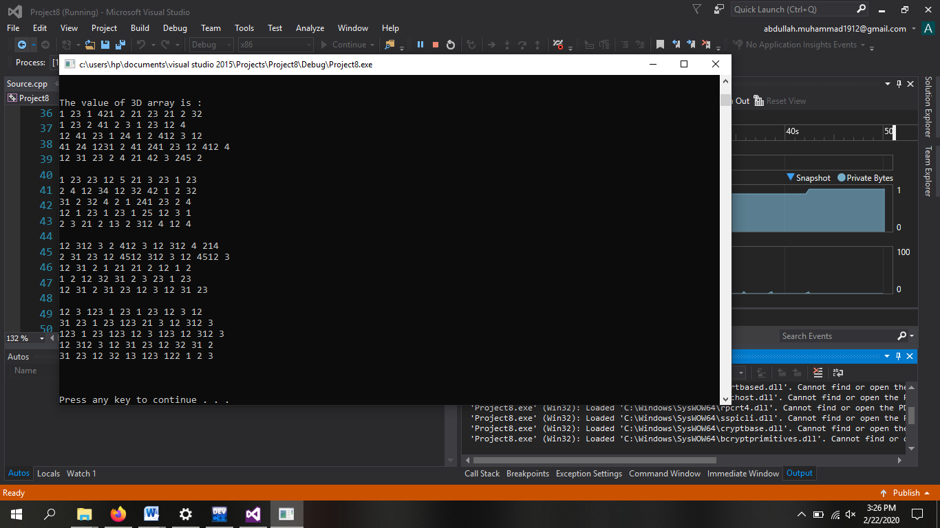

***Question # 8:***

***PROGRAM:***

#include <iostream>

using namespace std;

int main()

{

cout << "This program will help to make a user-defined 2D array " << endl;

int **Double = NULL;

int *col = NULL;

int row = 0, column = 0;

cout <<endl<< "Enter the number of rows : ";

cin >> row;

col = new int[100]; // to store coloumns according to user

Double = new int*[row];

cout << endl;

for (int i = 0; i < row; i++)

{

cout << "Enter the number of column for "<<i+1<<" row : ";

cin >> column;

col[i] = column;

for (int j = 0; j < column; j++)

{

Double[i] = new int[column];

}

}

cout << endl;

for (int i = 0; i < row; i++)

{

for (int j = 0; j < col[i]; j++)

{

cout << "Enter value of " << i + 1 << " row and " << j + 1 << " coloumn : ";

cin >> Double[i][j];

}

cout << endl;

}

cout << "value of 2D Array : " << endl;

for (int i = 0; i < row; i++)

{

for (int j = 0; j < col[i]; j++)

{

cout << Double[i][j] << " ";

}

cout << endl;

}

delete[]Double;

Double = NULL;

delete[]col;

col = NULL;

cout << endl << endl;

system("pause");

}

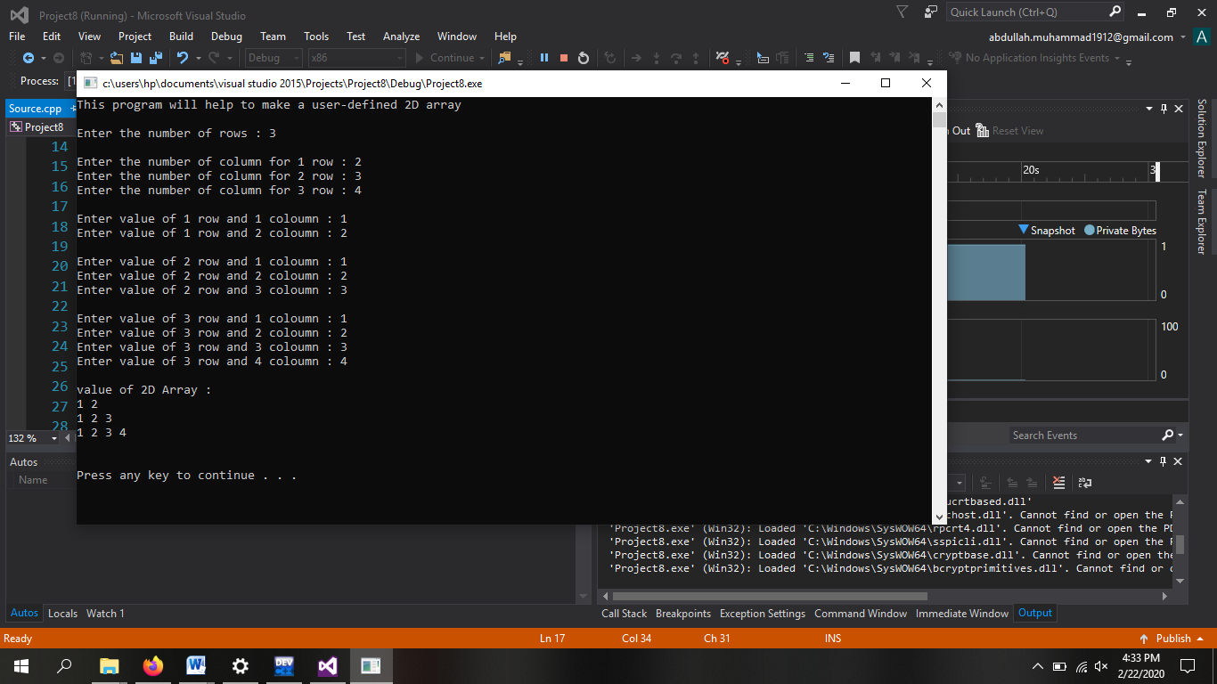

***Question # 9:***

***PROGRAM:***

#include <iostream>

using namespace std;

int FIB(int a);

int main()

{

cout << "This program will help to show the given Fibonacci number " << endl;

int size = 0;

cout << endl << "Enter the Number of the Fibonacci series : ";

cin >> size;

cout << endl << size <<" Fibonacci Number is : ";

cout << FIB(size);

cout << endl << endl;

system("pause");

}

int FIB(int a)

{

if (a == 0 || a == 1)

return a;

return (FIB(a - 1) + FIB(a - 2));

}

